Stock Market Design Document (SMD)
-- https://github.com/zhangbo2017/StockMarket

Document Version:1.0

Document Revision Status: Draft

Document Date:04/08/2020

Document Control Information

Document Owner: dlzbo@cn.ibm.com

Document Author: dlzbo@cn.ibm.com

Summary of Changes:

Version | Date | Short Description
1.0 | 04/08/2020 | Initial Version

Table of Contents
1.Overview 3
1.1 UserView Overview 3
1.2 AdminView Overview 3
2.Font Component Design 3
2.1 Component Design Overview 3
3.Backend MicroService Design 4
3.1 MicroService Design Overview 5
4.DataBase Design 5
4.1 DB Tables and Columus 6
5.AUTO Deploy Installation 7
5.1 Github 7
5.2 Jenkins 7
5.3 Docker 7
5.4 Open Source and Community Source 7

Overview

This Software System lets Admin to upload Stock Price of a Company(which is listed in a Stock Exchange) at different points of time. It supports multiple Stock Exchanges. And the registered Users should be able to generate various charts to perform Stock Market performance of various Companies or Sectors over certain period of time.
  - UserView Overview
Login in:
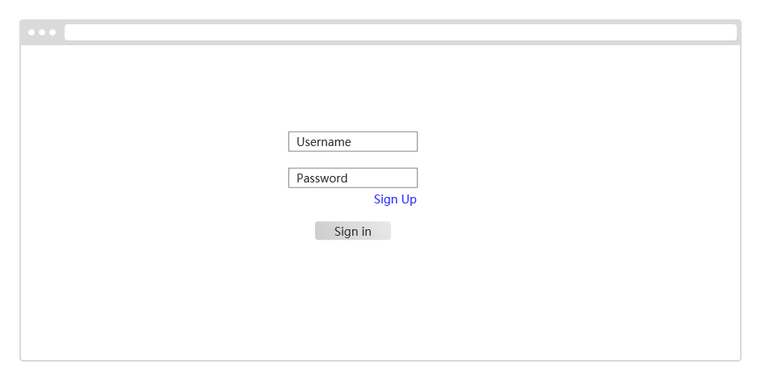
Sign Up:
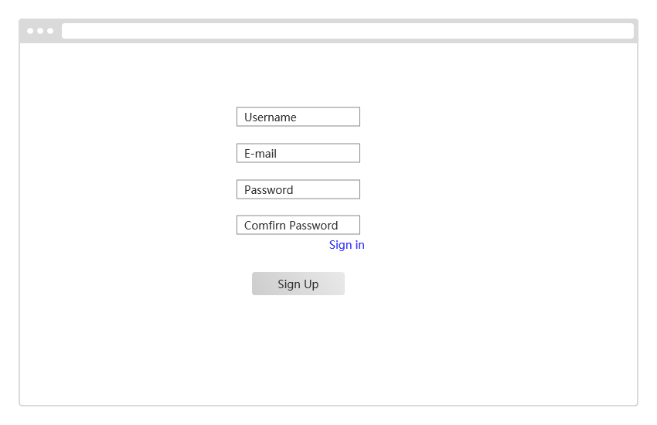
IPOs & Compare Company
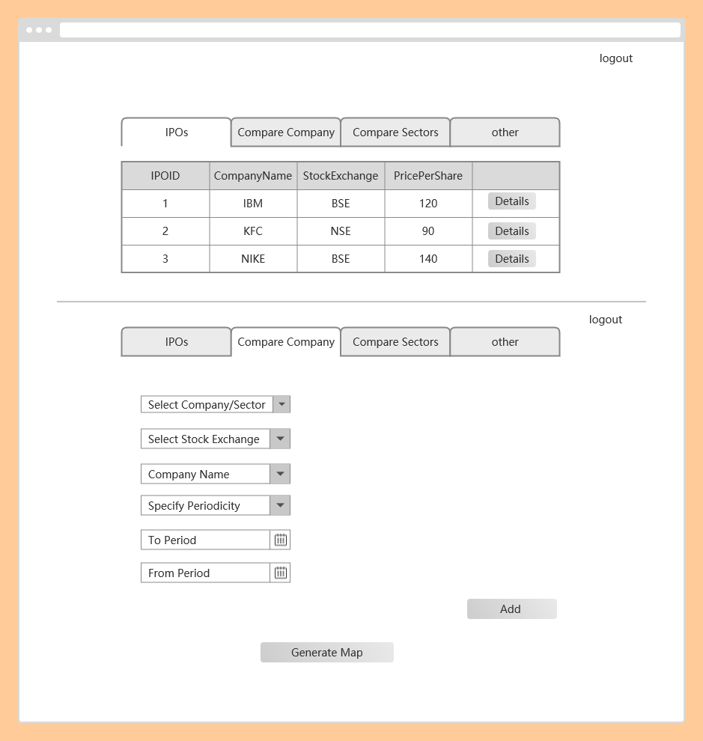
Compare Sectors & Other
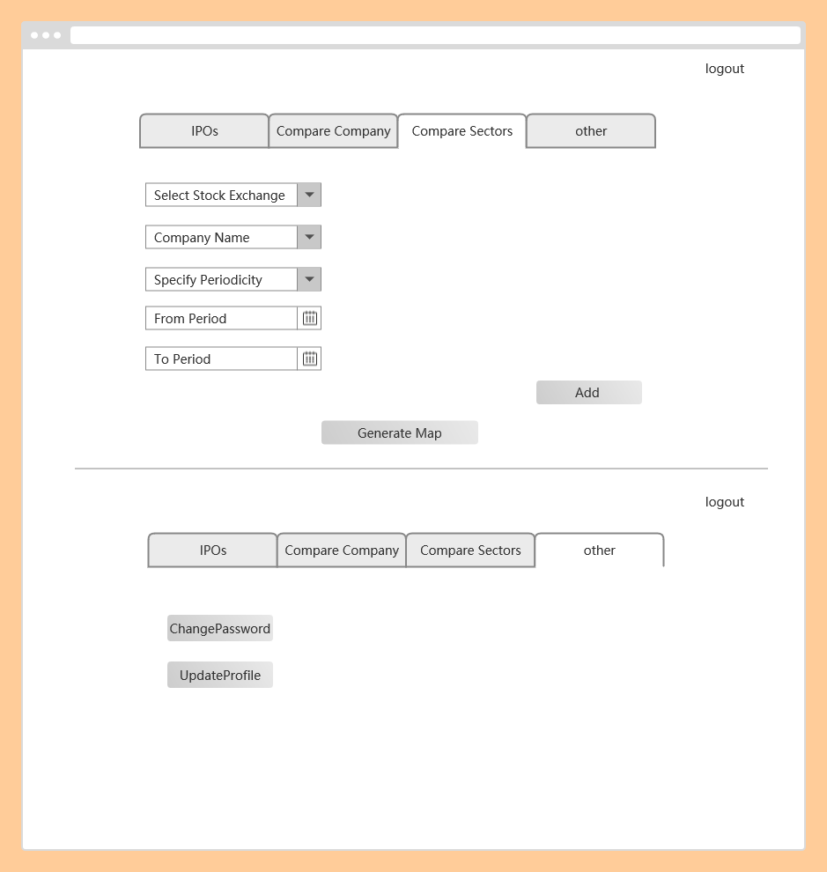

  - AdminView Overview
ImportData & Manager Company
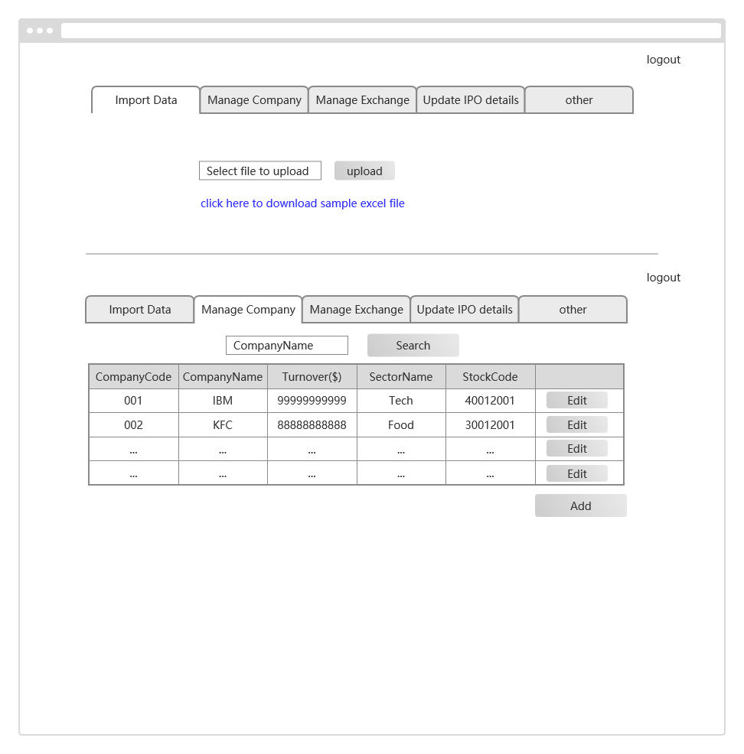
Manage Exchange & Update IPO details:
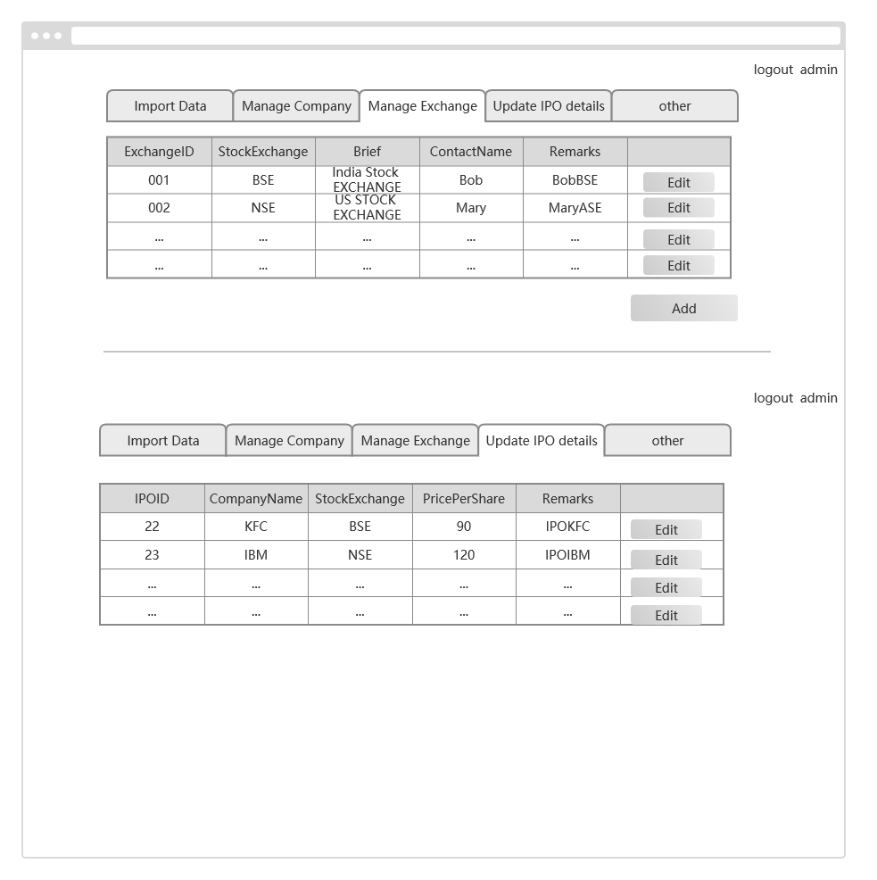

Font Component Design
  - Component Design Overview
- importExcel
- manageCompanies
- manageIPO
- manageExchange
- createCompany
- comparisonChats
- userLogin —for user and admin
- UserSignup

Backend MicroService Design
3.1 MicroService Design Overview
    - sm-EurekaService
    - sm-ZuulService
    - sm-UserService
    - sm-CompanyService
    - sm-SecurityService
    - sm-PriceService
    - sm-ExchangeService
    - sm-ImportExcelService
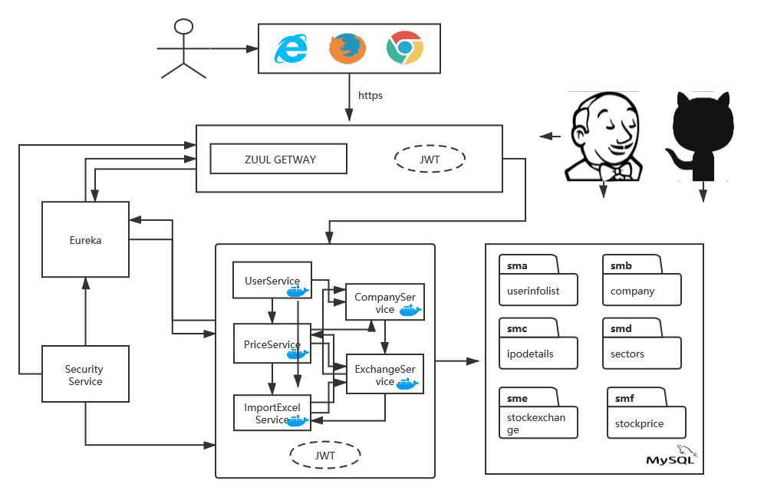

DataBase Design
4.1 DB Tables and Columus
1) sma.userinfolist
2) smb.company
3) smc.ipodetails
4)smd_sectors
5)sme_stockexchange
6)smf_stockprice

AUTO Deploy Installation
5.1 github--https://github.com/zhangbo2017/StockMarket
5.2 jenkins—http://localhost:8080
Plugin:github,maven,docker.ssh…
5.3 Docker—
5.4 Open Source and Community Source
https://jenkins.io/zh/
https://www.docker.com/
https://git-scm.com/
https://spring.io/
https://www.mysql.com/
https://angularjs.org/

